Applying Groups and Filters to Views
Most views in Project contain a table which provides a collection of columns/fields for display. These fields can be used to further refine the information displayed and potentially printed. Grouping and filtering are techniques to refine a view.
A group is a way to categorize and view information. A filter is a way to provide a subset of a collection of data. Filters hide rows of information that do not meet the condition of the filter. A highlight filter is an alternative to a regular filter and it is used to display all information, but visually shade the rows that meet the filter condition.
Groups and filters can applied together or separately.
If you apply a built-in group or filter option, you can tailor a view even if the field(s) used is not displayed.
Filters apply to information that is currently displayed. If you have a previous filter applied or an outline level applied, your filter may not produce the desired results.
How to Apply a Group
Click the View tab
Click the drop-down arrow on No Group in the Data group
Click the desired group or click More Groups
How to Apply a Column-Based Group
Locate the column/field you wish to group on
Click the drop-down arrown on the column heading and click Group by to display a menu of choices
Click the desired option
Click the column heading to select it and then click the drop-down arrow to generate a new choice Group on this field.
How to Remove a Group
Click the View tab
Click the drop-down arrow on Group Name in the Data group
Click No Group or Clear Group
How to Apply a Filter
Click the View tab
Click the drop-down arrow on No Filter in the Data group
Click the desired filter or click More Filters
If a dialog box appears requesting specific information, complete the information and click OK
How to Apply an AutoFilter
Locate the column/field you wish to filter on
Click the drop-down arrow onthe column heading and select or deselect the appropriate check boxes to set the filter conditions
Click OK to apply the filter
How to Apply a Highlight Filter
Click the View tab
Click the drop-down arrow on No Highlight in the Data group
Click the desired filter or click More Filters
If a dialog box appears requesting specific information, complete the information and click OK
How to Remove All Filters
Click the View tab
Click the drop-down arrow on Filter Name in the Data group
Click No Filter or Clear Filter
A fast way to remove all filters is to press F3.
What are Groups?
A group is a way to categorize and view information. A filter is a way to provide a subset of a collection of data.
Built-in Groups
Groups and filters can applied together or separately.
Task Groups Provided by Default
Group name | Fields/Colums using in the Group
Active vs. Inactive | Active
Auto scheduled vs. Manually scheduled | Task Mode
Complete vs. Incomplete | % Complete
Constraint Type | Constraint Type
Critical | Critical
Duration | Duration
Duration then Priority | Duration, Priority
Milestone | Milestone
Priority | Priority
Priority keeping outline structure | Project, Outline number, Priority
Resource | Resource Name
Status | Status

Resource Groups Provided by Default
Group name | Fields/columns used in the group
Complete and Incomplete Resources | % Work Complete
Resource Group | Group
Resource Type | Type
Standard Rate | Standard Rate
Work vs. Material | Type

Assignment Groups Provided by Default
Group Name | Fields/columns used in the group | Comments
Assignments keeping outline structure | Name, Task outline number | May only be used from Resource Usage view

Built-in Filters
Task Filters Provided by Default
Filter | Fields/Columns used in the Filter | Generates a Dialog Box for Input
Active Tasks | Active
Automatic scheduled tasks | Task Mode
Completed Tasks | % complete
Costs Greater Than… | Cost | X
Cost Overbudget | Cost v Baseline cost
Created After… | Created | X
Critical | Critical
Date Range… | Start, Finish | X
In Progress Tasks | Actual start, Actual finish
Incomplete tasks | % complete, % work complete for the assignment
Late tasks | Status
Late/Overbudget Tasks Assigned To… | Resource Name, baseline finish, Finish v Baseline finish, Cost v Baseline cost | X
Linked fields | Linked fields
Manually Scheduled Tasks | Task Mode
Milestones | Milestone
Resource Groups… | Resource Groups | X
Should Start By… | Start v Actual Start | X
Slipped/ Late Tasks | Baseline Finish, Finish v baseline finish, BCWS v BCWP
Slipping Tasks | Actual finish, Baseline finish, Finish v Baseline finish
Summary tasks | Summary
Task range… | ID (range of task ID numbers) | X
Tasks with a Task Calendar Assigned | Task Calendar
Tasks with Attachments | Objects, Notes
Tasks with Deadlines | Deadline
Tasks with estimated Durations | Estimated
Tasks with Fixed Dates | Constraint type, actual start
Tasks without Dates | Start, Finish
Tasks/Assignments with Overtime | Overtime Work
Top level tasks | Outline level
Unstarted tasks | Actual Start
Using Resource In Date Range… | Resource name, Start, Finish | X
Using Resource… | Resource Name | X
Work overbudget | Actual Work vs. Baseline Work

Resource filters provided are:
Resource Filters Provided by Default
Filter | Fields/Columns used in the Filter | Generates a Dialog Box for Input
Budget Resources | Budget
Costs Greater Than… | Cost | X
Cost Overbudget | Cost v Baseline cost
Created After… | Created | X
Date Range… | Start, Finish | X
Group… | Group | X
In Progress Assignments | Actual start, Actual finish
Linked Fields | Linked fields
Non-budget Resources | Budget
Overallocated Resources | Overallocated, Assignment
Resource Range… | ID | X
Resource - Cost… | Type | X
Resource - Material | Type
Resource - Work | Type
Resources With Attachments | Objects, Notes
Resource/Assignments With Overtime | Overtime Work
Should Start By… | Assignments, Actual Start | X
Should Start/Finish by... | Start, Finish | X
Slipped/Late Progress | Baseline finish, Finish, WCWS
Slipping Assignments | Actual finish, Baseline finish, Finish
Unstarted Assignments | Actual start
Work Complete | % complete
Work Incomplete | % complete, Work
Work Overbudget | Work v Baseline Work

Sorting Tasks or Resources in a View
Project initially arranges tasks according to ID number which is located in the far left column of the Gantt Chart view. To make it easier to work with your tasks, you may want to temporarily or permanently rearrange them. You can rearrange the order of tasks based on a particular type of information, including start date, finish date, priority, cost, and ID.
When you sort a project that contains summary tasks, Project maintains the outline levels and bases the sort on the summary task values. For example, if you sort a group of summary tasks by start date, Project bases the order on the start date of each summary task. Project then sorts the tasks within each summary task.
You can also sort resources in most resource views. By default, resources are arranged in ascending order based on the ID number, but you can sort resources by cost or name.
You can also perform a custom sort by specifying up to three sort fields. Sorting by more than one field is helpful when more than one task contains the same information in some fields. For example, if you sort by the duration and more than one task has the same duration, you can determine the order of those tasks by sorting by an additional field, such as the start date.
To sort information within a view:
Click the View tab
Click the drop-down arrow on Sort in the Data group
Click the desired option or click Sort By for more options
How to Sort Information
Click the View tab
Click the drop-down arrow on Sort in the Data group
Click the desired sort option or click Sort by
Choosing Permanently renumber tasks in the Sort By dialog box will renumber all rows in the view. This option is not recommended in a task view, such as Gantt Chart , since that will permanently change the order of items in your schedule.
How to Apply a Column Based Sort
Locate the column/field you wish to sort on
Click the drop-down arrow on the column heading and select Sort A to Z or Sort Z to A
How to Reset a Sort Back to Default
Click the View tab
Click the drop-down arrow on Sort in the Data group
Click by ID
Critical Path
What is a Critical Path
The Critical Path is the longest path of tasks through the network of tasks for the schedule. It represents the timeline of the schedule and establishes the end date for the project. It is the minimum time that it will take to complete the project. Tasks not included in the network of tasks will not be included in critical path calculation.
For a more accurate critical path calculation, all tasks should have a predecessor and a successor except the first and last tasks of a project.
Checking the contents of the predecessor and successor columns to make sure all tasks have valid entries is helpful.
Any task on the critical path is known as a Critical Task. If a critical task slips, the end date of the project will be negatively affected.
Scheduling factors contributing to the Critical Path calculation include:
Relationships between tasks
Lead and Lag time
Duration of tasks
Constraints
Task Calendars
Resource Availability
Resource Assignments
Project will automatically recalculate the critical path each time a task is changed. The calculation is making a forward and backward pass through the schedule looking for time gaps between tasks. This time gap is called slack which is also known as float. If a task has slack, it is considered non-critical. When a task has no slack, it is considered critical. Slack can be both a positive or negative value.
Every project schedule should include float or slack in order to address contingencies. No project will run exactly as planned. Float or slack will provide the extra time needed to handle unknown problems that will arise during the execution of a project.
There are 2 types of slack calculated in Project 2010:
Total slack is the amount of time a task can slip without affecting the end date of the project.
Free slack is the amount of time a task can slip before it affects its immediate successor task. If a task only has one successor, free slack will be the same as total slack.
This type of critcal path calculation is based on tasks.
Resources can also be critical within a project schedule. During the execution of the project, different resources will become critical at different points within the schedule. If a critical resource is not available at a critical point, the entire project could be affected as well as the ending date.
Frequently, during the execution of a project, a task that was not originally on the critical path will become critical. Careful tracking and monitoring of the critical path during the management of the project will help keep the project manager on track to achieve the goal of the projected end date.
Formatting Views to Display Critical Path
Slack is essentially scheduling breathing space for a project and occurs when a particular task can be delayed without affecting the end of the project. The greater the slack, the more breathing space you will have to help manage problems that may occur during the performance of the project. If a schedule fails to include slack, the plan for the schedule might be unobtainable. Since projects are typically never performed exactly as scheduled, slack becomes essential to achieving the goal date for the project.
Each time a task is changed in Project, the critical path is recalculated automatically.
Project provides the ability to format the Gantt Chart view to identify critical tasks and tasks with slack time.
To turn on Critical Task and Slack formatting:
Click the Format tab
Click Critical Tasks and click Slack as desired in the Bar Styles group
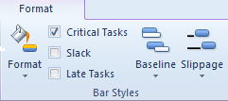
PLACEHOLDER
The critical path is shown as red Gantt bars and the non-critical tasks appear a blue Gantt bars. Once you have displayed the critical path, you will have a better understanding of the specific tasks which are driving the ending date of your project schedule.
Shortening the Critical Path
Viewing Resource Assignments
Once assignments are created, refining them and looking at them from different points of view is not only helpful but necessary. If resource allocations and future resource demands are your goals for using Project, taking a deeper look at the results of how the assignments were created will be essential.
Resource Usage View
The purpose of the Resource Usage view is to allow viewing and updating of assignments from the resource point of view. This view displays all assignments created for a resource as well as assignment details. Information may be viewed at any level of timescale detail that is appropriate for your project.
You will be able to use this view to answer the following questions:
How much availability does a resource have?
What is the cost of having a resource work on a task?
Are all of the tasks assigned to a resource?
How many hours is a resource assigned to a task?
Is a resource overallocated? (Overbooked)
What is the future demand for a resource for this project?
What is the total number of hours for a resource assigned to the project?
The Resource Usage view may be used for resource work distribution worksheets. When this view is printed, a timeframe may be added to allow for more focused printing. Insert a page break between resources to print separate reports for each resource.
Task Usage View
Task Usage view is very similar to the Resource Usage view, however, the content is shown from the task perspective. Each task is displayed with the resources assigned to the task. The scheduler will be able to see a complete picture of the details of assignments. This view may also be used for changing or fine tuning assignments. Information may be viewed at any level of timescale detail that is appropriate for your project.
What resources are assigned to a task?
Which tasks do not have a resource assigned?
What is the total cost and number of hours of a task?
What is the remaining work of a task?
What percent allocations are my resources assigned to tasks?
What is the distribution of work for all the resources on the task?
How to Display Resource Usage View
Click the View tab
Click Resource Usage in the Resource Views group
How to Display Task Usage View
Click the View tab
Click Task Usage in the Tasks Views group
How to Adjust Information in the TimePhased Grid on Resource Usage or Task Usage View
Click the Format tab
Click Add Details in the Details group
Select the desired field(s) on the left and click Show or select the desired field(s) on the right and click Hide
Click OK to apply the changes
Team Planner View
The purpose of this view is to show resources and their assignments using a Gantt style format. The team planner view will help the scheduler identify overallocations within the schedule, level workloads, reassign resources to tasks and identify problems in the schedule from the resource point of view.
Team Planner view is only available in Project 2010 Professional.
Team Planner view is divided into 2 sections. The upper section contains one row for each resource, with bars to the right representing assigned work. The lower section contains bars representing tasks without resources.
How to Display Team Planner View
Click the View tab
Click Team Planner in the Resoure Views group
PLACEHOLDER
Below is a chart to help with understanding how to interpret the informationin the view:
Team Planner View Legend
Feature | Description
A vertical orange line | Today’s date
Tasks colored in darker blue | Progress on the task
Teal colored tasks | Manually scheduled tasks
Gray colored tasks | External tasks
Light blue colored tasks | Un-started tasks
Gaps in timelines for resources | Under-allocated resource or unavailable
Red lines on the top and bottom of the task | Overallocated tasks
Resource name in red | Overallocated resource
Task bars colored black | Tasks that are late
Shaded day on calendar | Non-working day for the resource. This data is coming from the resource availability calendar
Top pane – pink blocks of time | Overallocated time

Below are some of the mouse shortcuts that will help you work with the information in this view.
Mouse Shortcuts for Team Planner View
Action | Result
Double click the resource name | Resource Information dialog box
Double click a work task bar | Task Information dialog box
Timescale density | Adjust as needed – lower right corner
Hover over task | Pop up of task details
Double click on timescale | Opens the timescale box to alter scale values
Right click on a task | More options:
Right click on an assignment – Reassign to: | This option presents a list of all resources in the schedule, including resources already assigned to the task. Select a resource to reassign to the task or select unassigned option and all assignments will be removed from the task.
Right click on an assignment – Inactivate: | Task will disappear from the Team Planner view. To reactive, return to Gantt chart view.

Only active tasks will show in the team planner view.
Leveling and Views that Show the Assignments
Understanding Overallocations
Each resource is assigned a calendar when entered on the Resource Sheet. The calendar is customized to contain the availability of the resource. When more work is assigned to a resource than time available on their resource calendar, the resource is considered to be overallocated. The overallocation calculation is looking at resource assignments on a minute by minute basis. If a resource is overbooked for even 1 minute, the resource is considered overallocated.
When a resource is overallocated, a red person symbol appears in the indicator column. This indicates that there is an overallocated resource assigned to the task but will not indicate which resource is affected. Even though resources are overallocated, assignments can continue to be created.
PLACEHOLDER
Real World Application of Scheduling: Shortening the Schedule and Resolving Resource Conflicts
Scheduling involves not only creating a detailed schedule and assigning resources, but it involves modifying the schedule to meet goals and to work with limitations. Typically there is a goal to complete the schedule on time and a common limitation is availability of resources. This section will address those areas.
Shortening the Schedule
Once you create your schedule, arrange the tasks, and assign resources to the tasks, you may realize that the schedule does not meet your original goals. You may have a deadline or a budget that you must meet. Listed below are several ways to shorten your schedule. The method you choose depends on your individual project and resources.
The best way to shorten your project is to shorten the critical path. The critical path includes those tasks that affect the duration of the project. If a critical task finishes late, it delays the entire project. If a critical task finishes early, it shortens the duration of the project. If you shorten the length of the critical path, you shorten the duration of your project, and your project finishes sooner.
Some options to consider for shortening the project schedule are:
Assign additional resources
Assign a resource to work overtime
Increase working time (calendar)
Break task into smaller tasks
Overlap key activities (multi-tasking)
Delete tasks
Redefine quality (less time on activities)
Break project into phases
Change dependencies of tasks
Resolving Resource Conflicts
The most common resource conflict is that a resource is overallocated. This means they have more work assigned to them then they can realistically complete in the given time frame.
While there are multiple ways to manage resource allocation, it is important to find and analyze resource overallocation and evaluate the overall effect on the project schedule.
Some options to consider for solving resource conflicts are:
Hire additional resources
Replace a resource on a task
Assign a resource to work overtime
Increase work time (calendar)
Break a task up and move a portion of a task till a resource is available
Delay the entire task until a resource is available
Adjust the division of work across the task (work contour)
Move or create a constraint on the task until the resource is available
Delete tasks
Change overlapping tasks into sequential tasks
Use Project’s leveling feature
Use Task Inspector to solve the problem
Use Team Planner to solve the problem
Notice the similarly with features already mentioned to shorten the schedule.
Views to Identify Overallocations
There are several views in Project that will help analyze resource overallocations. After an overallocation situation is discovered, research should be carried out to understand where the overallocation exists.
The views below will help locate these problems:
Gantt Chart view
Resource sheet
Resource graph
Resource allocation view
Team Planner
Task Usage view
Resource Usage view
Techniques to help work with overallocations will be illustrated next. You may have already discovered some of these on your own while using Project.
Using Indicators
In the Gantt Chart view, you will immediately be notified if there is an overallocated resource on a task when the red stick figure appears. If you hover the cursor on this icon, the display indicates resources are overallocated. This indicator is a handy and quick visual cue to identify overallocated resources.
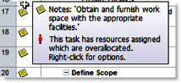
Overallocated Resource
Using the Resource Allocation View
The Resource Allocation view is a combination view that shows resource assignments in a Resource Usage pane along with a personal Gantt chart in the lower pane. The advantage of this view is you can see both numerically and visually what a resource is working on and use either the upper or lower pane to quickly make modifications.
To use the Resource Allocation view to identify resource commitment issues:
How to Display Resource Allocation View
Click the View tab
Click the drop down arrow on Other Views in the Resource Views group
Click More Views
Click Resource Allocation
Click Apply
Methods for Resolving Resource Conflicts
In this section, you will be exposed to many different methods for analyzing and resolving resource conflicts. It will be up to you to determine the correct mix of options for the schedule. Some methods will be more manually driven, while other methods will take advantage of some automatic features in Project. Methods that are more automated may have more of a ripple effect that aren’t expected so be sure to carefully choose the appropriate method. This list of methods is not meant to cover every possible scenario, but instead is presented to give suggested scenarios that are popular and easy to use. No order of priority is indicated with this list.
Using Indicator Suggestions
For tasks that have a red stick figure in the indicators column, that means there is a resource conflict on the task. You can use shortcuts in Project to help fix that. Simply right click on the indicator field or name of the task and apply one of the options listed such as: Fix in Task Inspector or Reschedule to Available Date.
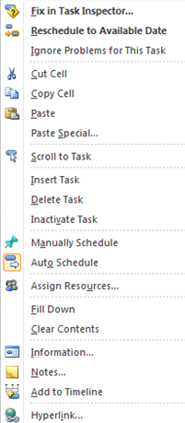
Context Menu from Overallocated Resource
Using Task Inspector
Another option to evaluate and solve problems with the schedule is Task Inspector. Using this option gives you a pane to the left side of the Entry table. The advantage of Task Inspector is it provides critical information about the task and information about what is occurring at a specific time and gives you options to correct any issues, including hyperlinks to the feature or area where you can make a change.
How to Apply Task Inspector
Click the Task tab
Click Inspect in the Tasks group
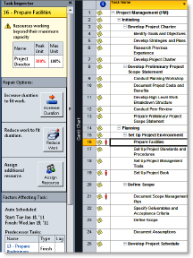
Task Inspector
Don’t forget to consider the ripple effect of making a change to one task. As other tasks respond to this change, you may see a change in the critical path or introduce other resource conflicts.
Changing Resource Assignments
When you look at resource assignments individually, you might see that one resource is very overworked; however, when you look at resources collectively, you might notice that some resources are underworked. One of the best ways to solve resource issues is to more equitably distribute the work. For example, Ricardo is assigned to a task at 150% while Angelica is assigned to a task at the exact same time at 25%. If you can find a way to shift some of Ricardo’s work to Angelica, you will take better advantage of the availability of both resources. Changing assignments can be done in many different views sch as Task Usage or Resource Usage view.
When you return to the Resource Allocation view, it will recalculate and remove that task from the resource you had selected. You may need to reselect that resource again if you want to see an updated lower pane and be able to continue making adjustments.
Move a Task Until a Resource is Available
Sometimes the resource assigned to a task is the only person with the skill set that can do the work. In this case the only option is to move the task until the resource is available. One technique for moving a task is to shift by a timeperiod (e.g. week), another technique is to reschedule the task until the resource is available.
Moving a task will create a constraint on the task. To delay a resource assignment:
How to Move Tasks to Account for Resource Limitations
Select the desired task (clck on the row ID number or task name)
Click the Task tab
Click the drop down arrow on Move in the Tasks group
Click the desired option
Assigning a Work Contour
When you assign a resource to a task, Project spreads the work out evenly over the duration of the task unless you specify otherwise. For example, if you assign a resource 100% to work 80 hours on a ten-day task, Project assigns eight hours of work per day. This is a flat contour.
Not all tasks require that the work be spread equally (a flat contour). For example, consider the building of a fine custom wooden cabinet, which is one task in a project that involves furnishing a house. The carpenter purchases the wood and other components, which requires trips to several specialty stores. He spreads the trip out over several days, while using some of his time to finish his previous project. Then he works full days for three weeks cutting and assembling the cabinet. In the middle of construction, he puts in some overtime.
After the construction phase is completed, he stains the wood, which takes two hours. The stain has to dry overnight. The next day, he applies a coat of varnish, which takes two hours. It, too, has to dry overnight.
The next day, he sands the varnish and applies another coat, which takes three hours. He applies three more coats of varnish, repeating the progress.
On the last day, he buffs the final coat, which takes an hour. Most of the work on the cabinet occurs during the middle of the project, peaking during a few days of overtime. Work at the beginning and end of the task is part-time.
You can change the work contour by manually modify the working hours in the timephased grid on the right side of the Task Usage or Resource Usage views.
Using the Team Planner View
The Team Planner view is very visually pleasing and allows you to manage your schedule by resources instead of by task. Overallocations can be quickly corrected here and the impact on the resource or other resources is also quickly visible.
To use the Team Planner View to solve an overallocation:
Locate the task that is causing a conflict (red lines above/below highlight the task), and simply drag the task to a new time period for the same resource or drag it to another resource.
Optionally – You can right click on the task and take advantage of features available in the short-cut menu (such as reassign to another resource).
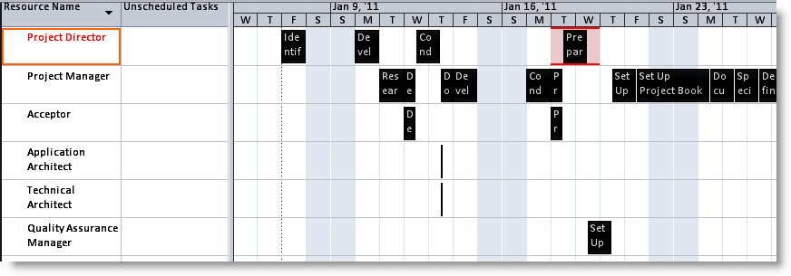
Team Planner View
The Team Planner view is also an easy way to assign tasks that currently do not have resources assigned to them. Unassigned tasks will appear at the bottom of the Team Planner view and can be dragged and dropped to the appropriate resource.
Dragging a task to a new location will create a constraint on that task since you are essentially forcing it to happen a particular time. If you want to avoid constraints, use the Gantt Chart view and make other adjustments such as changing links or reassigning tasks.
Applying Leveling Features
Leveling is a feature in Project that can be used to solve overallocations. While the software can’t dream up a creative solution, it is able to shift, delay, and split tasks to take advantage of open spaces in your project where resources might be underallocated or where tasks can be delayed without shifting the end date. Should you choose, you can also indicate that your end date is flexible so there are more options for leveling to correct overallocations. Before you use leveling, be sure to consider the following scenarios and options.
These are three leveling scenarios you can choose:
Level Selection – use this option when you are in a task view and want to fix overallocated resources on specific tasks. This will leave overallocations for those same resources on other tasks untouched. Typically this option can help when you need to make sure you meet your commitments on the selected task(s), but do not want to address other tasks at the same time.
Level Resource – use this option when you are in a resource view and want to fix overallocations by resource. This choice would be suggested when you know that the availability of a specific resource will not change and you have to get the work done using this limited availability.
Level All – this option is when you want to fix overallocations across the entire project across all resources.
When you click Leveling Options, the following dialog box appears:
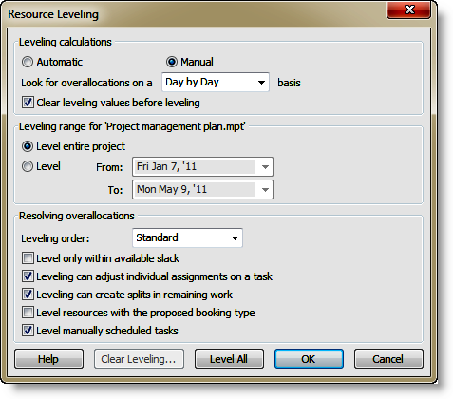
Resource Leveling Diagram
Please consider the following when selecting your options:
Automatic is not recommended since it will level your project continuously without warning. Tasks will be delayed before you realize anything has happened.
While Project offers an auto leveling feature to resolve overallocation, it is recommended that the project manager resolve overallocation manually. Overallocation can be a complex issue and requires analysis. Utilizing the auto leveling feature can diminish your ability to analyze and uncover the root cause of the overallocation.
Consider changing Leveling order to “Priority, Standard” if you have set priority numbers on your tasks.
Best Practice – Only use priority numbers to lock exception tasks down. For example, setting a task to a priority number of 1000 will make sure that they task does not move when you level. Essentially you are setting the task to be highest priority.
The Team Planner view is an interactive format allowing you to drag and drop activities directly on the right portion of the screen to alleviate overallocations. Also of note is that unassigned tasks will appear at the bottom and can be assigned to resources by dragging and dropping them on the grid on the right.
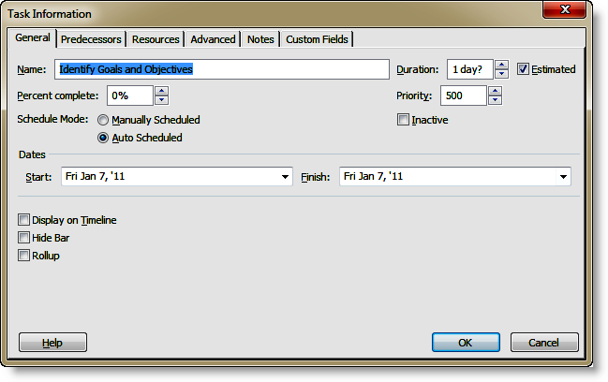
Task Information Dialog – General Tab
“Level only within available slack” attempts to delay only non-critical tasks. The drawback to this feature is it limits Project’s ability to fix things.
Best Practice – Run leveling first with the “Level only within available slack” option enabled to protect your critical path and observe the benefits before turning this option off and running leveling.
“Leveling can adjust individual assignments on a task” means when a task is staffed with multiple resources, Project has the flexibility to move work resource by resource instead of moving the entire task and all resources at once.
“Leveling can create splits in remaining work” means a task can be split as needed to get around other tasks that can’t be moved.
Be sure to review the splits created in your Project and undo the action if necessary. For example, if the result of this is a task that is split into 10 pieces, this is probably not a good result.
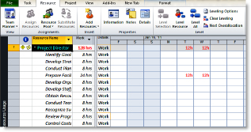
Leveling
To level your project:
How to Apply Resource Leveling
Click the Resource tab
Click Leveling Options in the Level group
Choose desired options and click OK to save the settings or click Level Now to apply resource leveling immediately
To level by a specific resource, click OK on the leveling options and click Level Resource to choose a specific resource.
How to Clear Resource Leveling
Click the Resource tab
Click Clear Leveling in the Level group

